**The Tableau HR Scorecard: Measuring Success in Talent Management**

1. **INTRODUCTION**

The Tableau HR Scorecard is a framework designed to measure and evaluate the success of talent management strategies within an organization. It provides a way for HR professionals and business leaders to track and analyze key performance indicators (KPIs) related to workforce planning, recruitment, retention, and development.

* 1. **Overview**

**1.1.1 Objectives**

* Measuring HR Deliverables and objectives
* Quantitatively demonstrate HR’s contribution to firm’s financial results and profitability
* Measure the degree of alignment between business strategy and HR deliverables
* HR Scorecard links the things people do with the strategy of the firm.

**1.1.2 Methodology**

* The first step in building a talented workforce is attracting the right individuals
* Investing in employee growth is an investment in the organization’s future
* Transparent performance management systems enable regular feedback, goal alignment, and skill development
* Anticipating and preparing for future leadership needs is critical

**2. PROBLEM DEFINITION & DESIGN THINKING**

**2.1 Empathy Map** 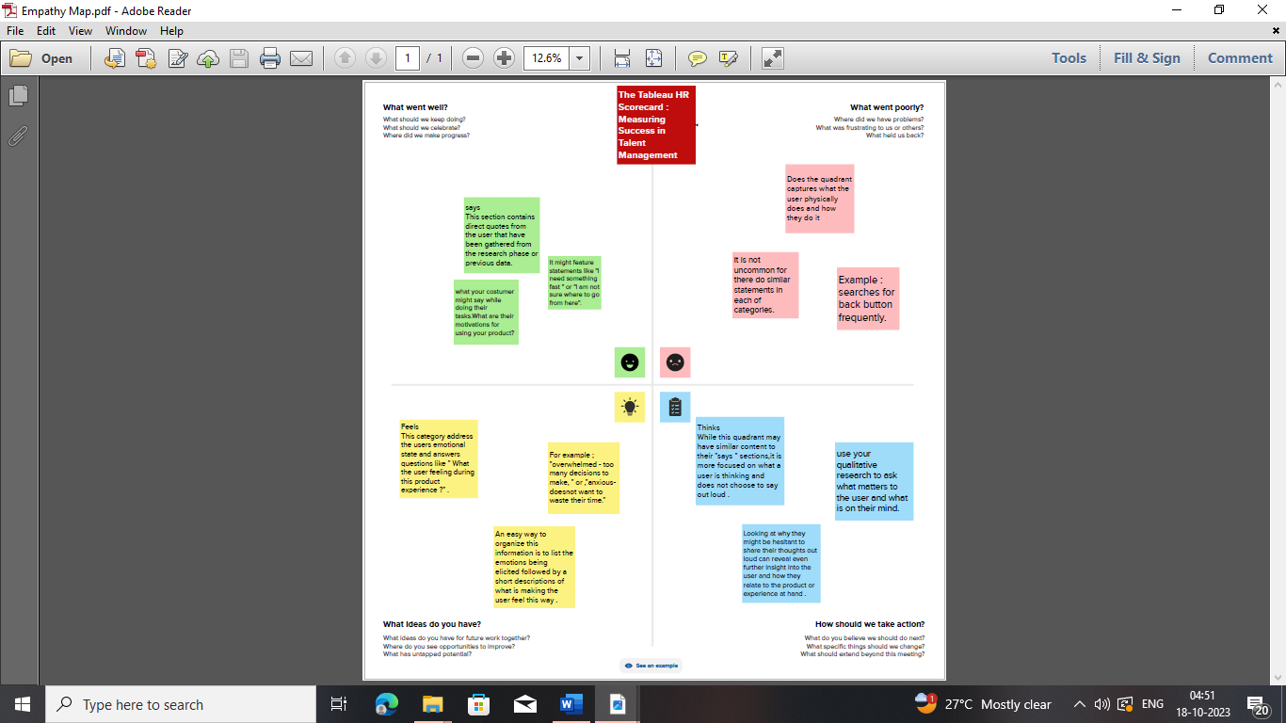

**2.2 Ideation & Brainstorming Map**

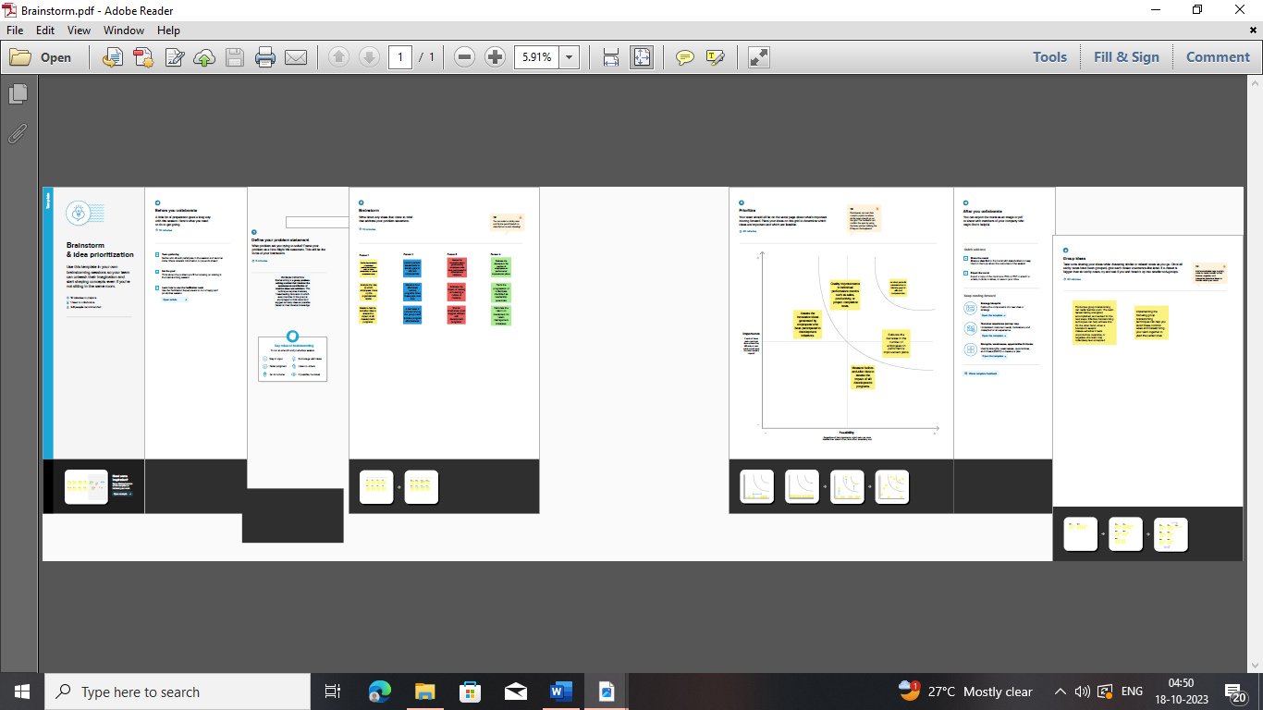

**3.RESULT**

It includes KPIs such as employee engagement, manager satisfaction with HR support, and candidate experience. Internal Process Perspective: This perspective assesses the effectiveness and efficiency of HR processes, such as recruiting, onboarding, performance management, and employee development.

**3.1 Visualizations**

**Lines of Talent Management** 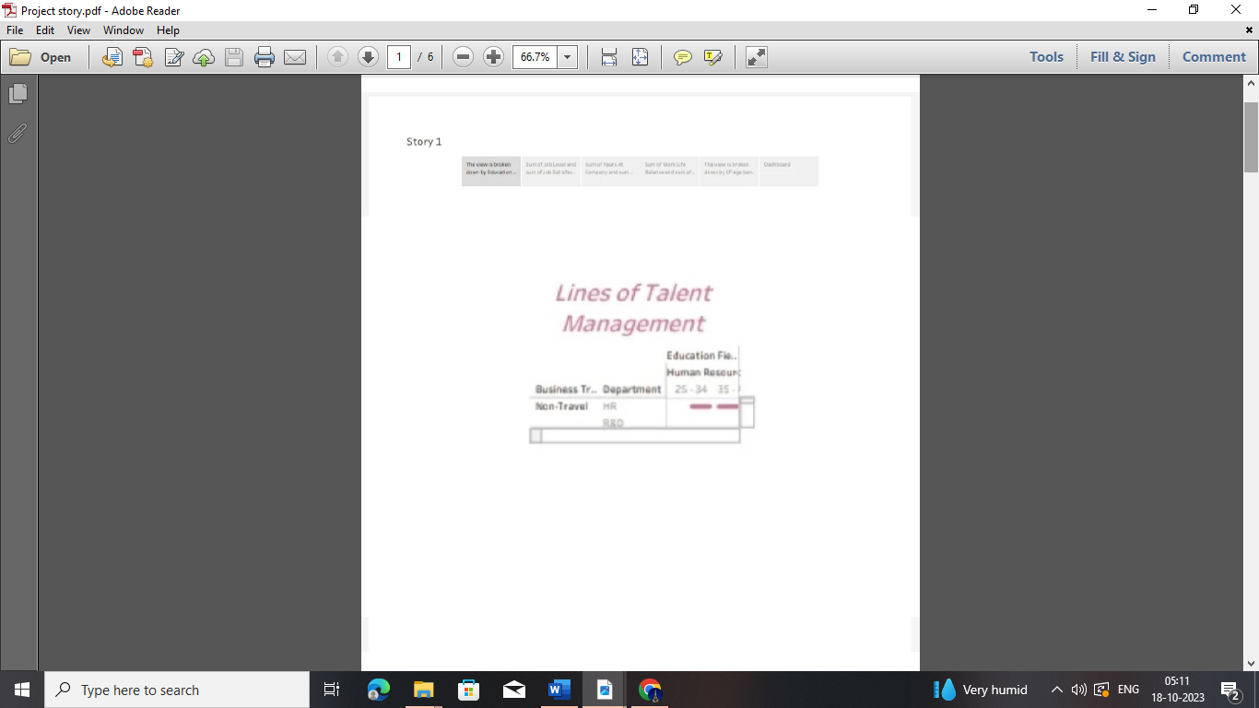

**Measuring Success in Talent Management**

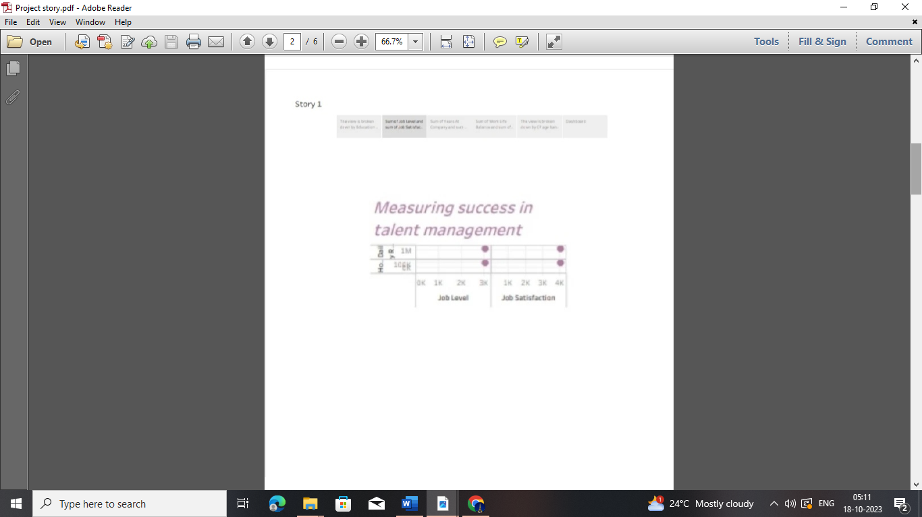

**Talent Management**

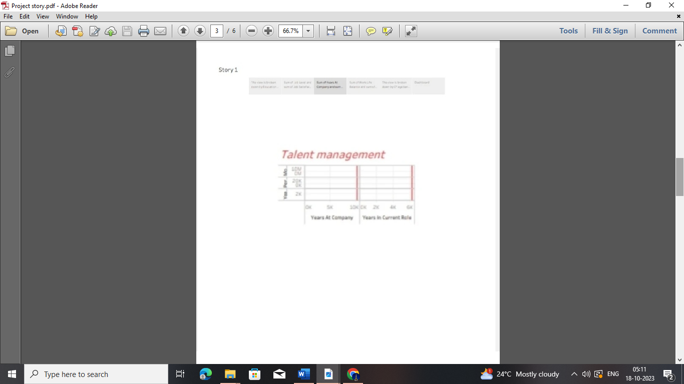

The HR Scorecard

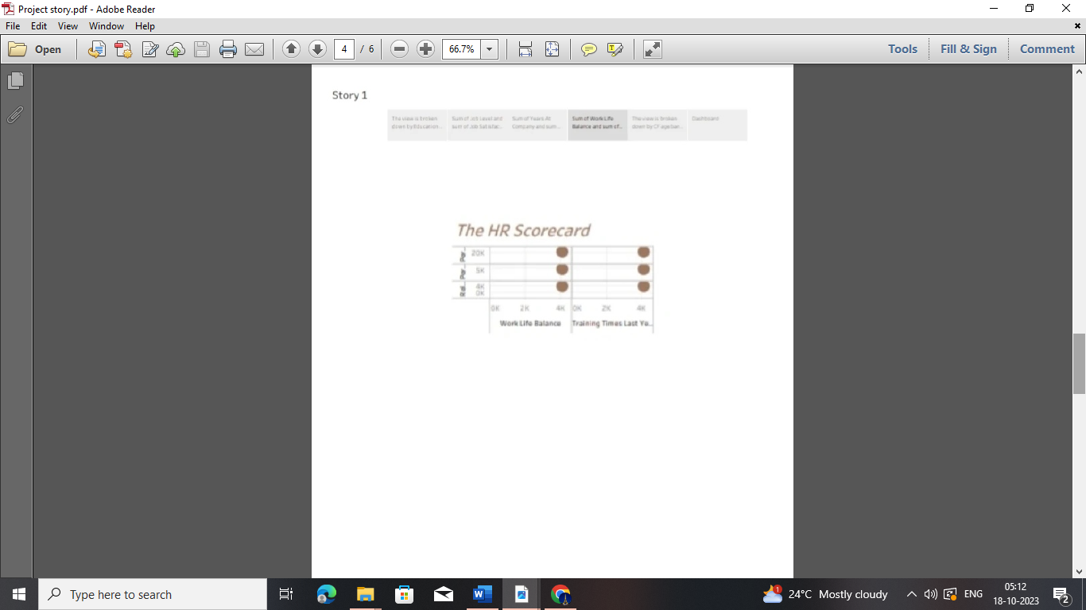

**Scorecard Talent Management**

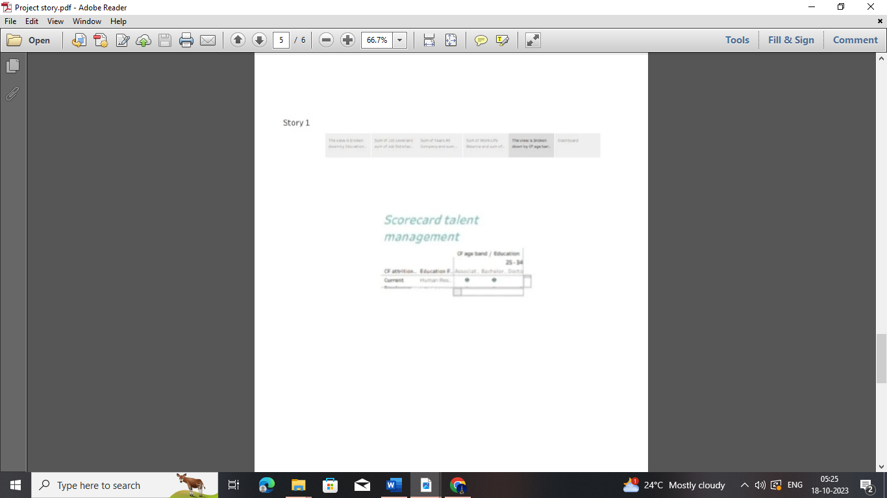

**3.2 Dashboard**

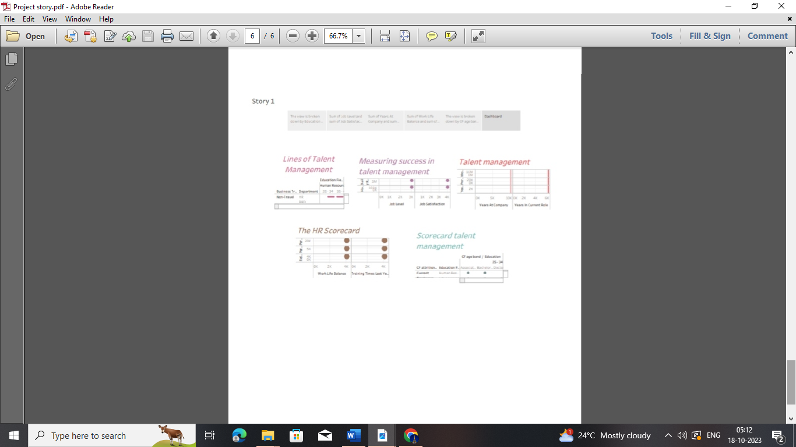

**3.3 Story**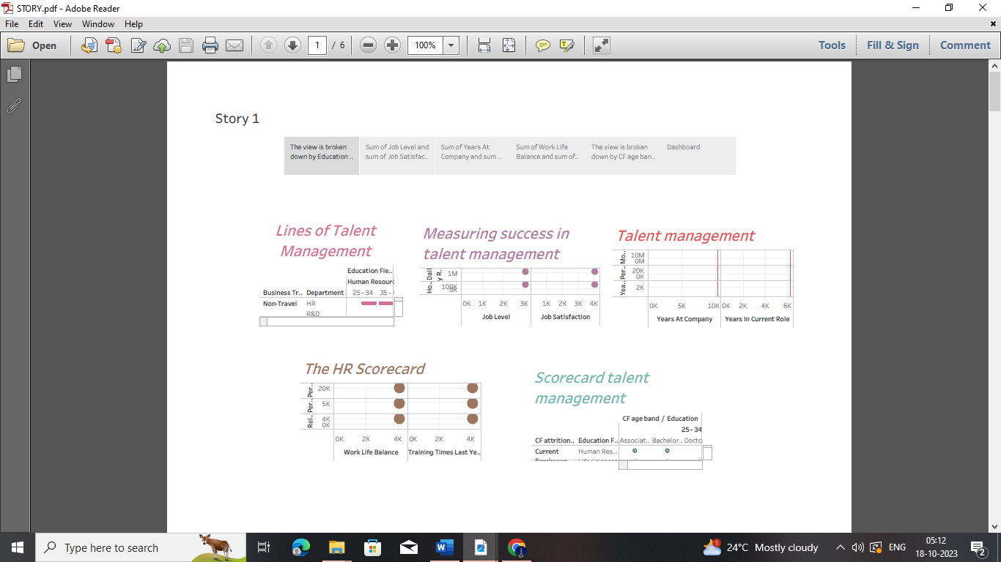

* **Lines of Talent Management**
* **Measuring Success in Talent Management**
* **Talent Management**
* **The HR Scorecard**
* **Scorecard Talent Management**

**4. ADVANTAGES & DISADVANTAGES**

**4.1 Advantages**

With a scorecard, HR leaders can assess the department's performance in their way and within a set structure that can be understood across the organization. Here are the top four benefits of an HR balanced scorecard:

**1. Gives structure to the strategy**

A scorecard helps keep the goals at the center, uses specific parameters to track progress, and follows initiatives for monitoring actions.

**2. Improves performance reporting**

The HR scorecard can come in handy for designing performance reports and dashboards, ensuring the focus remains on critical strategic issues and helping the HR department monitor the execution of its plan.

**4.2 Disadvantages**

One of the disadvantages of the HR scorecard is that measuring intangibles is difficult, if not impossible, without imparting a degree of subjectivity on the part of HR staff. Subjectivity undermines the validity of data and, therefore, limits the credibility of HR and its ability to prove its worth to an organization.

* Brings structure to business strategy.
* Makes communication easier.
* Facilitates better alignment.
* Connects the individual worker to organizational goals.
* It must be tailored to the organization.
* It needs buy-in from leadership to be successful.
* It can get complicated.

**5. CONCLUSION**

At the end can say that talent management process has provide new ways to Human Resource department to handle problems faced in hiring talent. By the help of talent management process companies are hiring right person for the right job as per their job requirement and description.

**6.FUTURE SCOPE**

The HR scorecard is a strategic HR measurement system that helps to measure, manage, and improve the strategic role of the HR department. The HR scorecard is meant to measure leading HR indicators of business performance. Leading indicators are measurements that predict future business growth.

**7.APPENDIX**

A. Score Code: